

ARMY PUBLIC SCHOOL,BHOPAL

*SUBMITTED TO:--*

*MR. DEEPAK HARDIKAR*

*(PGT IP)*

*SUBMITTED BY:--*

*ADITYA RAJ SINGH CHAUHAN*

*SANJIV RAI*

*RAJ KUMAR TRIPATHI*

IP PROJECT :-

MESSAGING SERVICE;

HELL MESSANGER

**CERTIFICATE**

THIS IS TO CERTIFY THAT THE ORIGINAL AND GENUINE INVESTIGATION WORK HAS BEEN CARRIED OUT TO INVESTIGATE ABOUT THE SUBJECT MATTER AND THE RELATED DATA COLLECTION AND INVESTIGATION HAS BEEN COMPLETED SOLELY, SINCERELY AND SATISFACTORILY BY aditya raj singh chauhan, sanjiv rai and raj kumar tripathi OF CLASS XII-A , ARMY PUBLIC SCHOOL, REGARDING HIS PROJECT TITLED” Online shopping(kharedo.com)”.

TEACHER INCHARGE

MR.Deepak Hardikar

(PGT Information Practices)

Signature

ACKNOWLEDGEMENT

It would be my utmost pleasure to express my sincere thanks to my IP teacher.

MR. DEEPAK HARDIKAR in providing a helping hand in this project. His valuable guidance, support and supervision all through this project are responsible for attaining its present form.

I would also like to convey my regards to MR. R K PAWAR SIR (lab attendant) for their help in putting up this project.

**INTRODUCTION TO OBJECT ORIENDTED LANGAUAGE**

* An object is a identifiable entity with some characteristics and behavior.
* A class is a blueprint that represents a set of similar kind of objects.
* There are variables to hold data, called member variables or attributes.
* value of these variables define the state of an object.
* There are member functions/operation/methods and define the behavior of objects.

**DATA BASE ABSTRACTION**

Database system provides the users that much information that is required by them. This means that the system does not disclose all the details of date, rather it hides certain details of how the date is stored and maintained. Database implementation can be done through three general levels:

* Internal Level (physical level)
* Conceptual Level.
* External Level (View Level)

**INHERITENCE**

It is splendid concept of object oriented languages. It has the capability to express the inheritance relationship, reusability and due to transitive nature of inheritance, that is why it is use in OO language.

Different forms of Inheritance are:

* Single inheritance
* Multiple Inheritance
* Hierarchical Inheritance
* Multilevel Inheritance
* Hybrid Inheritance

**INTRODUCTION TO JAVA**

JAVA is a third generation programming language and a platform. It is used in crating various type of computer applications. Java is also a platform of combination of some hardware and software for application development. The Java platform is new soft ware platform different from many other platforms: It is designed to deliver and to run highly interactive, dynamic and secure applications on networked computer system.

**HISTORY OF JAVA**

Java started as an elite project (code name green) to find a way of allowing different electronic devices such as TV tops and controllers to use a common language. This language foe electronic device was originally named Oak but failed to find niche despite its potential. In 1995 java was formally announced and 2006 the NetBeans IDE 5.0 is released (Sun open-sourced java EE components as the Glassfish Project to java.net. Java SE and ME initial components are released as open source.

Some Versions

* 1996 : IDK 1.0 ships
* 1997 L JKD 1.1
* 1998 L JKD 1.2
* 1999-2001 : JKD 1.3

**CHARACTERISTICS OF JAVA**

* + Write once run anywhere (WORA)
  + Light Weight Code
  + Security
  + OOPS Language (near to real world)
  + Platform independent
  + Supports Multimedia

**INTRODUCTION TO MYSQL**

MySQL is a freely available open source Relational Database Management System (RDBMS) that users Structured Query Languages (SQL). It is downloadable from the [www.mysql.org](http://www.mysql.org)In a MySQL database, information is stored in Tables. A single MySQL database can contain many tables at once store thousands of individual records. It provides with the rich set of features that supports a secure environment for storing, maintaining, and accessing date. MySQL is a fast, reliable, sealable, and alternative to many of the commercial RDBMSs available today.

**HISTORY OF MYSQL**

MySQL. Was created and is supported by MySQL AB a company based in Sweden ([www.bysql.com](http://www.bysql.com)). MySQL has been named after Monty’s daughter my. The logo of MySQL.

The dolphin, is named as “sakila”.

**CHARACTERISTICS OF MYSQL**

* Speed.
* Ease of use.
* Free of cost.
* Query Language Support.
* Portability.
* Connectivity.
* Security.

**INTRODUCTION TO PROJECT**

This project is about database connectivity. Hell Messenger is a simple messaging service which provides an easy and interesting way to convey our message to other students of school who are also registered to the application.

Administration section is also provided in the project so that if any unwanted message is conveyed to any student then he/she can complain about it. Overall, this is a project which needs a server to run on for working properly.

**FRONT END & BACKEND**

This is responsible for collection input in various forms from the user and processing it to confirm to a specification the backend can be used. The front acts an interface between user and the backend.

**FRONTEND INTERFACE**

1. For software applications, frontend is the same as user interface.

2. In server application, the server of the program is often called the frontend and the server part is called backend.

**NEED**

1. Clear 5. Consistent

2. Concise 6. Attractive

3. User Friendly 7. Efficient

4. Responsive

**BACKEND DATE BASE**

A backend database that is accessed by the users through an external application rather that by application programming stores within the date base its self. A backend data base stores data but does not include end-user applications elements such as stores queries, forms, macros or reports.

**REQUIREMENT**

The Required Databases Are –:

**Table REGISTRATION**

|  |  |  |  |
| --- | --- | --- | --- |
|  |  |  |  |
|  |  |  |  |
|  |  |  |  |
|  |  |  |  |
| C:\Users\student\Desktop\ASR\sql.regist.PNG |  |  |  |
|  |  |  |  |
|  |  |  |  |
|  |  |  |  |

**Table MESSAGE**

|  |  |  |  |
| --- | --- | --- | --- |
|  |  |  |  |
| C:\Users\student\Desktop\ASR\sql.mssg.PNG |  |  |  |
|  |  |  |  |
|  |  |  |  |
|  |  |  |  |
|  |  |  |  |
|  |  |  |  |
|  |  |  |  |

|  |  |  |  |
| --- | --- | --- | --- |
|  |  |  |  |
|  |  |  |  |
|  | **Table COMPLAINT** |  |  |
|  | C:\Users\student\Desktop\ASR\sql.complain.PNG |  |  |
|  |  |  |  |
|  |  |  |  |
|  |  |  |  |
|  |  |  |  |
|  |  |  |  |
|  |  |  |  |

**Table FEEDBACK**

|  |  |  |  |
| --- | --- | --- | --- |
|  |  |  |  |
|  |  |  |  |
|  |  |  |  |
|  | C:\Users\student\Desktop\ASR\sql.feed.PNG |  |  |
|  |  |  |  |
|  |  |  |  |
|  |  |  |  |
|  |  |  |  |
|  |  |  |  |
|  |  |  |  |

**GETTING STARTED WITH HELL MESSANGER**

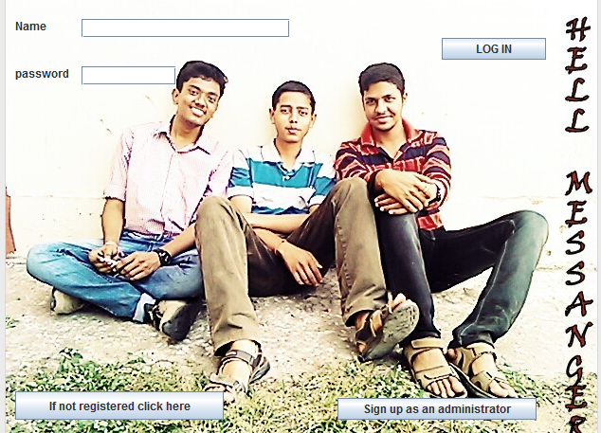

***SOURCE CODE FOR HOME :---***

*CODE FOR LOG IN BUTTON :---*

**String name=t1.getText()**

**String pass=txtpassword.getText();**

**try {**

**Class.forName("java.sql.Driver");**

**Connection con=DriverManager.getConnection("jdbc:mysql://localhost:3306/yochat","root","mysql");**

**Statement stmt=con.createStatement();**

**String hh="select * from regist where name='"+name+"' and password='"+pass+"'" ;**

**ResultSet rs=stmt.executeQuery(hh);**

**rs.first();**

**int uid=rs.getInt("userid");**

**String nam= rs.getString("name");**

**String passw=rs.getString("password");**

**if(passw.equalsIgnoreCase(pass) && nam.equalsIgnoreCase(name)) {**

**Uhome jk=new Uhome(uid);**

**jk.setVisible(true);**

**this.setVisible(false);**

**} else**

**JOptionPane.showMessageDialog(this,"you probably entered wrong details");**

**} catch(Exception e) {**

**JOptionPane.showMessageDialog(this,e.getMessage()); }**

*CODE FOR (SIGN UP AS AN ADMINISTRATOR BUTTON) :---*

**Asignup aa=new Asignup();**

**aa.setVisible(true);**

**this.setVisible(false);**

**}**

*CODE FOR (IF NOT REGISTERED CLICK HERE) BUTTON :---*

**Uregistration hh=new Uregistration();**

**hh.setVisible(true);**

**this.setVisible(false);**

**CREATION OF NEW ACCOUNT AND CONNECTEDFRAMES**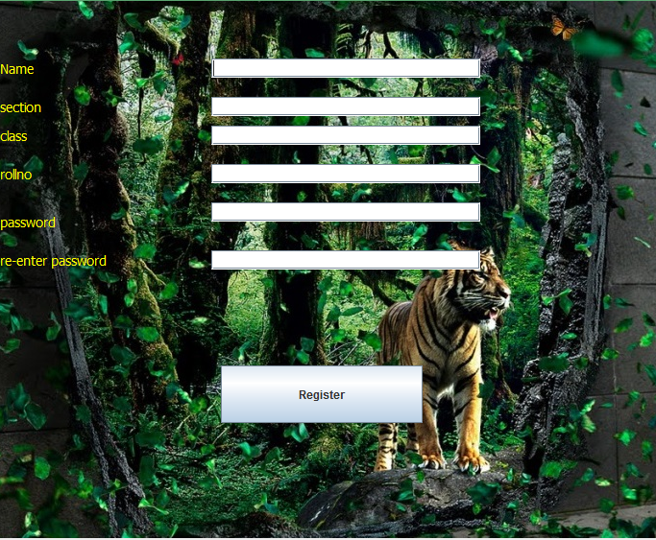

***SOURCE CODE FOR REGISTRATION :---***

*CODE FOR (REGISTER) BUTTON :---*

**String name,sec,pass,repass;**

**int clas,rno,user;**

**name=txtname.getText();**

**sec=txtsection.getText();**

**pass=txtpassword.getText();**

**repass=txtrepassword.getText();**

**clas=Integer.parseInt(txtclass.getText());**

**rno=Integer.parseInt(txtrno.getText());**

**if(pass.equals(repass))**

**{**

**Uagreement kk=new Uagreement(name,clas,sec,rno,pass);**

**kk.setVisible(true);**

**this.setVisible(false);**

**}**

**else**

**{**

**JOptionPane.showMessageDialog(this,"your passwords do not match");**

**txtpassword.setText("");**

**txtrepassword.setText("");**

**}**

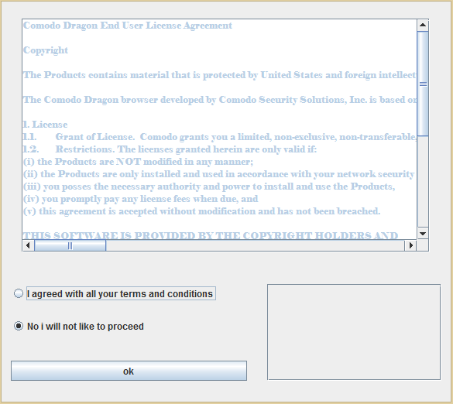

**AGREEMENT**

**FRAME**

***SOURCE CODE FOR AGREEMENT :---***

*CODE FOR (OK) BUTTON :---*

**String mm=tamm.getText();**

**int messageid,user;**

**if(optyes.isSelected())**

**{try**

**{**

**Class.forName("java.sql.Driver");**

**Connection con=DriverManager.getConnection("jdbc:mysql://localhost:3306/yochat","root","mysql");**

**Statement stmt=con.createStatement();**

**String x="SELECT * FROM REGIST";**

**ResultSet rs=stmt.executeQuery(x);**

**if(rs.last())**

**user=rs.getInt("userid")+1;**

**else**

**user=1;**

**String quer = "INSERT INTO REGIST VALUES("+user+",'"+name+"',"+clas+",'"+sec+"',"+rno+",'"+pass+"')";**

**stmt.executeUpdate(quer);**

**JOptionPane.showMessageDialog(this,"Congratulations you are registered");**

**String yoyo="SELECT * FROM MESSAG";**

**ResultSet rss=stmt.executeQuery(yoyo);**

**if(rss.last())**

**messageid=rss.getInt("messageid")+1;**

**else**

**messageid=1;**

**String hahaha="INSERT INTO MESSAG VALUES("+messageid+","+1+","+user+",'"+mm+"','unseen')";**

**stmt.executeUpdate(hahaha);**

**Uhome gg=new Uhome(user);**

**gg.setVisible(true);**

**this.setVisible(false);**

**}**

**catch(Exception f)**

**{ JOptionPane.showMessageDialog(this,f.getMessage());}**

**}**

**else**

**{**

**JOptionPane.showMessageDialog(this,"Thank you");**

**System.exit(0);}**

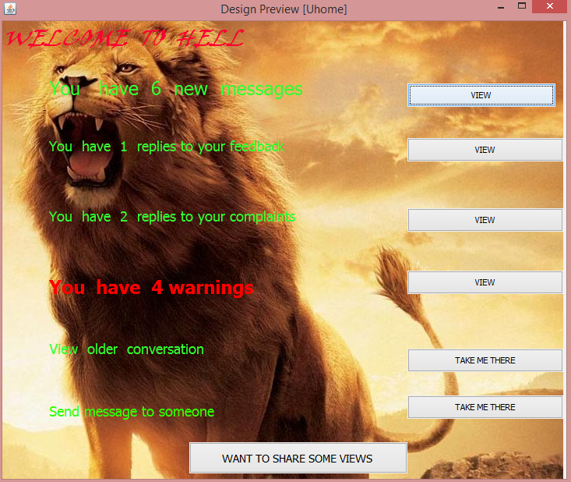**HOME**

**FRAME**

***SOURCE CODE FOR HOME (FRAME) :---***

*CODE FOR (VIEW BUTTON FOR FEEDBACK) :---*

**Ufeedback j=new Ufeedback(id);**

**j.setVisible(true);**

**this.setVisible(false);**

**}**

*CODE FOR (VIEW BUTTON FOR OLDER CONVERSATION) :---*

**Uolderconversation1 g=new Uolderconversation1(id);**

**g.setVisible(true);**

**this.setVisible(false);**

**}**

*CODE FOR (VIEW BUTTON FOR OLDER WARNING) :---*

**Uwarning j=new Uwarning(id);**

**j.setVisible(true);**

**this.setVisible(false);**

**}**

*CODE FOR (VIEW BUTTON FOR COMPLAINT) :---*

**Ureplycomplaint h=new Ureplycomplaint(id);**

**h.setVisible(true);**

**this.setVisible(false);**

**}**

*CODE FOR (VIEW BUTTON FOR FEEDBACK REPLIES) :---*

**Ufeedbackreply h=new Ufeedbackreply(id);**

**h.setVisible(true);**

**this.setVisible(false);**

**}**

*CODE FOR (VIEW BUTTON FOR NEW MESSAGES) :---*

**Unewmessages h=new Unewmessages(id);**

**h.setVisible(true);**

**this.setVisible(false);**

*CODE FOR (TAKE ME THERE BUTTON FOR NEW SEND MESSAGE) :---*

**Umessagesend f=new Umessagesend(id);**

**f.setVisible(true);**

**this.setVisible(false);**

**}**

*CODE FOR WINDOW OPEN EVENT:---*

**int user=id;**

**System.out.println(""+id);**

**try**

**{**

**Class.forName("java.sql.Driver");**

**Connection con=DriverManager.getConnection("jdbc:mysql://localhost:3306/yochat","root","mysql");**

**Statement stmt=con.createStatement();**

**String a="SELECT COUNT(*) as hahaha FROM MESSAG WHERE Status='unseen' and receiver="+user;**

**ResultSet rsa=stmt.executeQuery(a);**

**rsa.first();**

**int f=rsa.getInt("hahaha");**

**if(f==0)**

**{**

**l1.setText("you have no new messages");**

**}**

**else**

**{**

**l1.setText("you have "+ f +" unread messages");**

**gg.setVisible(true);**

**}**

**String b="SELECT COUNT(*) as hahaha FROM feed WHERE senderid="+user+" and status='unseen'";**

**ResultSet rsb=stmt.executeQuery(b);**

**rsb.first();**

**int g=rsb.getInt("hahaha");**

**if(g==0)**

**{**

**l2.setText("you have no replies to your feedbacks");**

**}**

**else**

**{**

**l2.setText("you have "+ g +" replies to your feedbacks");**

**gg1.setVisible(true);**

**}**

**String c="SELECT COUNT(*) as hahaha FROM complain WHERE hero="+user+" and statushero='unseen'";**

**ResultSet rsc=stmt.executeQuery(c);**

**rsc.first();**

**int h=rsc.getInt("hahaha");**

**if(h==0)**

**{**

**l3.setText("you have no replies to your complaints");**

**}**

**else**

**{**

**l3.setText("you have "+ h +" replies to your complaints");**

**gg2.setVisible(true);**

**}**

**String d="SELECT COUNT(*) as hahaha FROM complain WHERE daku="+user+" and statusdaku='unseen'";**

**ResultSet rsd=stmt.executeQuery(d);**

**rsd.first();**

**int i=rsd.getInt("hahaha");**

**if(i==0)**

**{**

**l4.setText("you have no warnings");**

**}**

**else**

**{**

**l4.setText("you have "+ i +"warnings");**

**gg3.setVisible(true);**

**}**

**}**

**catch(Exception e)**

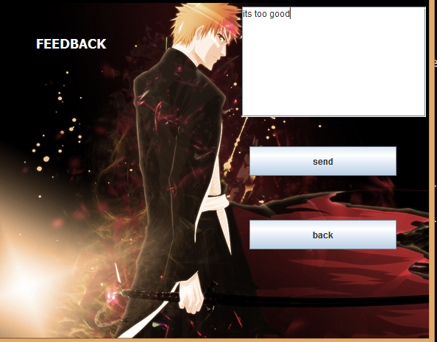 **{**

**JOptionPane.showMessageDialog(this,e.getMessage());**

**}**

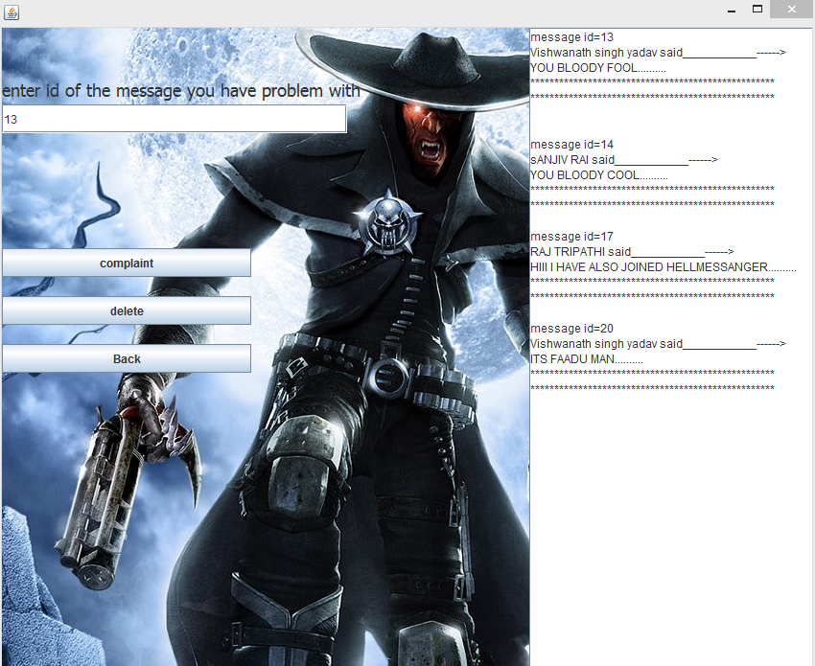**CONNECTED FRAMES TO HOME**

**NEW MESSAGES FRAME**

***SOURCE CODE FOR NEW MESSAGE :---***

*CODE FOR (BACK BUTTON) :---*

**int userid=id;**

**try {**

**Class.forName("java.sql.Driver");**

**Connection con=DriverManager.getConnection("jdbc:mysql://localhost:3306/yochat","root","mysql");**

**Statement stmt=con.createStatement();**

**String x="update messag set status='yoyo' where receiver="+userid;**

**stmt.executeUpdate(x);**

**Uhome nh=new Uhome(id);**

**nh.setVisible(true);**

**this.setVisible(false);**

**} catch(Exception e) {**

**}**

**}**

*CODE FOR (COMPLAIN BUTTON) :---*

**int user=id,cid;**

**int i=0,j=0,k=0,l=9;**

**String g;**

**int kkk=Integer.parseInt(txtmid.getText());**

**try**

**{**

**Class.forName("java.sql.Driver");**

**Connection con=DriverManager.getConnection("jdbc:mysql://localhost:3306/yochat","root","mysql");**

**Statement stmt=con.createStatement();**

**String a="select * from messag where messageid="+kkk;**

**ResultSet rsx=stmt.executeQuery(a);**

**rsx.first();**

**int se=rsx.getInt("sender");**

**int r=rsx.getInt("receiver");**

**String me=rsx.getString("message");**

**String b="select * from complain";**

**ResultSet rsa=stmt.executeQuery(b);**

**if(rsa.last())**

**cid=rsa.getInt("complaintid")+1;**

**else**

**cid=1;**

**String z="insert into complain values("+cid+","+r+","+se+",'"+me+"',null,null,'seen','seen',"+kkk+")";**

**stmt.executeUpdate(z);**

**String kk="delete from messag where messageid="+kkk;**

**stmt.executeUpdate(kk);**

**tam.setText("");**

**do**

**{**

**String x="select * from messag where receiver="+user+" and status='unseen'";**

**ResultSet rs=stmt.executeQuery(x);**

**rs.last();**

**int ccc=rs.getInt("messageid");**

**rs.first();**

**k=j;**

**if(k!=0)**

**{do**

**{**

**rs.next();**

**k--;**

**}while(k!=0);**

**}**

**int cccc=rs.getInt("messageid");**

**if(ccc==cccc)**

**l=0;**

**if(l==1)**

**i=1;**

**if(i==0) {**

**int mid=rs.getInt("messageid");**

**int s=rs.getInt("sender");**

**String m=rs.getString("message");**

**String hh="select * from regist where userid="+s;**

**ResultSet rshh=stmt.executeQuery(hh);**

**rshh.first();**

**String sname=rshh.getString("name");**

**tam.append("message id="+mid+"\n");**

**tam.append(sname+" said___________------>\n");**

**tam.append(m+"\n");**

**tam.append("***************************************************\n");**

**tam.append("***************************************************\n");**

**j++;} }while(i==0 && i!=1);**

**}catch(Exception e){} }**

*CODE FOR (DELETE BUTTON) :---*

**int user=id;**

**int i=0,j=0,k=0,l=9;**

**String g;**

**int kkk=Integer.parseInt(txtmid.getText());**

**try**

**{**

**Class.forName("java.sql.Driver");**

**Connection con=DriverManager.getConnection("jdbc:mysql://localhost:3306/yochat","root","mysql");**

**Statement stmt=con.createStatement();**

**String kk="delete from messag where messageid="+kkk;**

**stmt.executeUpdate(kk);**

**tam.setText("");**

**do**

**{**

**String x="select * from messag where receiver="+user+" and status='unseen'";**

**ResultSet rs=stmt.executeQuery(x);**

**rs.last();**

**int ccc=rs.getInt("messageid");**

**rs.first();**

**k=j;**

**if(k!=0)**

**{**

**do{**

**rs.next();**

**k--;**

**}while(k!=0);**

**}**

**int cccc=rs.getInt("messageid");**

**if(ccc==cccc)**

**l=0;**

**if(l==1)**

**i=1;**

**if(i==0)**

**{**

**int mid=rs.getInt("messageid");**

**int s=rs.getInt("sender");**

**String m=rs.getString("message");**

**String hh="select * from regist where userid="+s;**

**ResultSet rshh=stmt.executeQuery(hh);**

**rshh.first();**

**String sname=rshh.getString("name");**

**tam.append("message id="+mid+"\n");**

**tam.append(sname+" said___________------>\n");**

**tam.append(m+"\n");**

**tam.append("***************************************************\n");**

**tam.append("***************************************************\n");**

**j++;**

**l++; }}while(i==0 && i!=1);**

**}**

**catch(Exception e)**

**{ }**

**}**

*CODE FOR (WINDOW OPEN EVENT) :---*

**int user=id;**

**int i=0,j=0,k=0,l=9;**

**String g;**

**try**

**{**

**Class.forName("java.sql.Driver");**

**Connection con=DriverManager.getConnection("jdbc:mysql://localhost:3306/yochat","root","mysql");**

**Statement stmt=con.createStatement();**

**do**

**{**

**String x="select * from messag where receiver="+user+" and status='unseen'";**

**ResultSet rs=stmt.executeQuery(x);**

**rs.last();**

**int ccc=rs.getInt("messageid");**

**rs.first();**

**k=j;**

**if(k!=0)**

**{**

**do {**

**rs.next();**

**k--;**

**}while(k!=0);**

**}**

**int cccc=rs.getInt("messageid");**

**if(ccc==cccc)**

**l=0;**

**if(l==1)**

**i=1;**

**if(i==0) {**

**int mid=rs.getInt("messageid");**

**int s=rs.getInt("sender");**

**String m=rs.getString("message");**

**String hh="select * from regist where userid="+s;**

**ResultSet rshh=stmt.executeQuery(hh);**

**rshh.first();**

**String sname=rshh.getString("name");**

**tam.append("message id="+mid+"\n");**

**tam.append(sname+" said___________------>\n");**

**tam.append(m+"\n");**

**tam.append("***************************************************\n");**

**tam.append("***************************************************\n");**

**j++;**

**l++;**

**}**

**}while(i==0 && i!=1);**

**}**

**catch(Exception e)**

**{}**

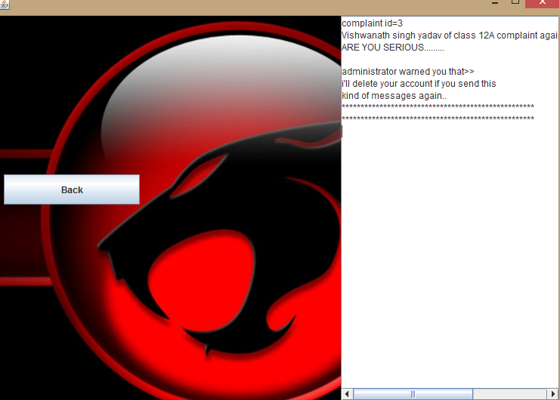

**WARNING**

**FRAME**

***SOURCE CODE FOR WARNING :---***

*CODE FOR (WINDOW OPEN EVENT) :---*

**int user=id;**

**int i=0,j=0,k=0,l=9;**

**try**

**{**

**Class.forName("java.sql.Driver");**

**Connection con=DriverManager.getConnection("jdbc:mysql://localhost:3306/yochat","root","mysql");**

**Statement stmt=con.createStatement();**

**do {**

**String x="select * from complain where daku="+user+" and statusdaku='unseen'";**

**ResultSet rs=stmt.executeQuery(x);**

**rs.last();**

**int ccc=rs.getInt("complaintid");**

**rs.first();**

**k=j;**

**if(k!=0)**

**{**

**do {**

**rs.next();**

**k--;**

**}while(k!=0);**

**}**

**int cccc=rs.getInt("complaintid");**

**if(ccc==cccc)**

**l=0;**

**if(l==1)**

**i=1;**

**if(i==0) {**

**int mid=rs.getInt("complaintid");**

**int s=rs.getInt("hero");**

**String m=rs.getString("content");**

**String war=rs.getString("warning");**

**String hh="select * from regist where userid="+s;**

**ResultSet rshh=stmt.executeQuery(hh);**

**rshh.first();**

**String sname=rshh.getString("name");**

**int cla=rshh.getInt("class");**

**String sec=rshh.getString("section");**

**tam.append("complaint id="+mid+"\n");**

**tam.append(sname+" of class "+cla+sec+" complaint against you about the message>>>>");**

**tam.append("\n");**

**tam.append(m+"\n");**

**tam.append("\n");**

**tam.append("administrator warned you that>>\n");**

**tam.append(war+"\n");**

**tam.append("***************************************************\n");**

**tam.append("***************************************************\n");**

**j++;**

**l++;}**

**}while(i==0 && i!=1);**

**}**

**catch(Exception e){}**

**}**

*CODE FOR (BACK BUTTON) :---*

**int user=id;**

**try {**

**Class.forName("java.sql.Driver");**

**Connectioncon=DriverManager.getConnection("jdbc:mysql://localhost:3306/yochat","root","mysql");**

**Statement stmt=con.createStatement();**

**String x="update complain set statusdaku='yoyo' where daku="+user;**

**stmt.executeUpdate(x);**

**Uhome nh=new Uhome(id);**

**nh.setVisible(true);**

**this.setVisible(false);**

**} catch(Exception e) {**

**}**

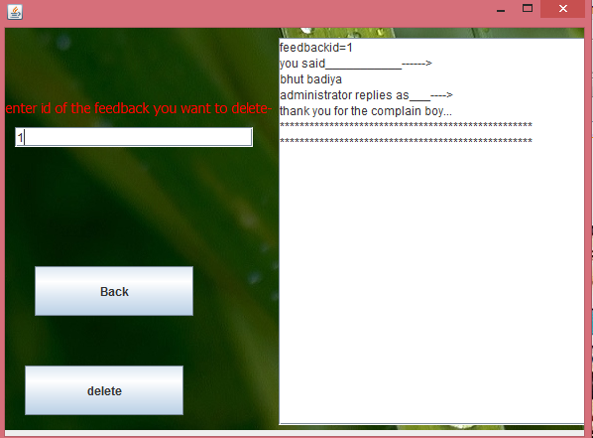

**FEEDBACK**

**REPLY**

**FRAME**

***SOURCE CODE FOR FEEDBACK FRAME :--***

*CODE FOR (BACK BUTTON) :---*

**int user=id;**

**try {**

**Class.forName("java.sql.Driver");**

**Connection con=DriverManager.getConnection("jdbc:mysql://localhost:3306/yochat","root","mysql");**

**Statement stmt=con.createStatement();**

**String x="update feed set status='seen' where senderid ="+user;**

**stmt.executeUpdate(x);**

**Uhome nh=new Uhome(id);**

**nh.setVisible(true);**

**this.setVisible(false);**

**} catch(Exception e)**

**{**

**}**

**}**

*CODE FOR (DELETE BUTTON) :---*

**tam.setText("");**

**int mid=Integer.parseInt(txtmid.getText());**

**int user=id;**

**int j=0;**

**try {**

**Class.forName("java.sql.Driver");**

**Connection con=DriverManager.getConnection("jdbc:mysql://localhost:3306/yochat","root","mysql");**

**Statement stmt=con.createStatement();**

**String ff="delete from feed where feedbackid="+mid;**

**stmt.executeUpdate(ff);**

**String x="select * from feed where senderid="+user+" and status='unseen'";**

**ResultSet rs=stmt.executeQuery(x);**

**rs.first();**

**do**

**{**

**if(j==0)**

**rs.first();**

**String m=rs.getString("feedback");**

**int fid=rs.getInt("feedbackid");**

**String r=rs.getString("reply");**

**tam.append("feedbackid="+fid+"\n");**

**tam.append("you said___________------>\n");**

**tam.append(m+"\n");**

**tam.append("administrator replies as___---->\n");**

**tam.append(r+"\n");**

**tam.append("***************************************************\n");**

**tam.append("***************************************************\n");**

**j++;**

**}**

**while(rs.next());**

**}**

**catch(Exception e)**

**{**

**}**

**txtmid.setText("");**

**}**

*CODE FOR (WINDOW OPEN EVENT) :---*

**int user=id;**

**int j=0;**

**try**

**{**

**Class.forName("java.sql.Driver");**

**Connection con=DriverManager.getConnection("jdbc:mysql://localhost:3306/yochat","root","mysql");**

**Statement stmt=con.createStatement();**

**String x="select * from feed where senderid="+user+" and status='unseen'";**

**ResultSet rs=stmt.executeQuery(x);**

**rs.first();**

**do**

**{**

**if(j==0)**

**rs.first();**

**String m=rs.getString("feedback");**

**int fid=rs.getInt("feedbackid");**

**String r=rs.getString("reply");**

**tam.append("feedbackid="+fid+"\n");**

**tam.append("you said___________------>\n");**

**tam.append(m+"\n");**

**tam.append("administrator replies as___---->\n");**

**tam.append(r+"\n");**

**tam.append("***************************************************\n");**

**tam.append("***************************************************\n");**

**j++;**

**}while(rs.next());**

**}**

**catch(Exception e)**

**{**

**}**

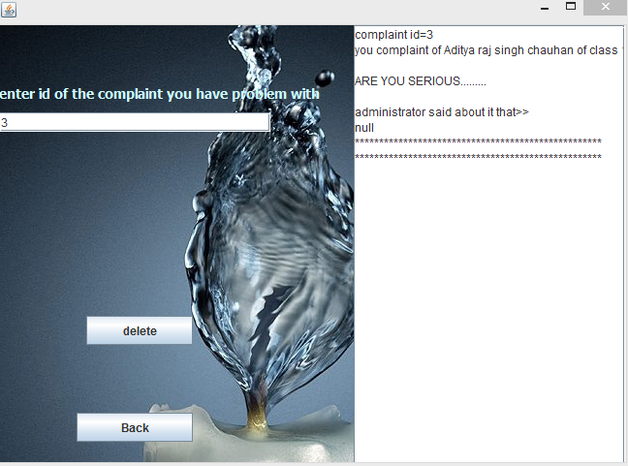

**COMPLAINT**

**FRAME**

***SOURCE CODE FOR COMPLAINT FRAME:--***

*CODE FOR (WINDOW OPEN EVENT) :---*

**int user=id;**

**int i=0,j=0,k=0,l=9;**

**try{**

**Class.forName("java.sql.Driver");**

**Connection con=DriverManager.getConnection("jdbc:mysql://localhost:3306/yochat","root","mysql");**

**Statement stmt=con.createStatement();**

**do {**

**String x="select * from complain where hero="+user+" and statushero='unseen'";**

**ResultSet rs=stmt.executeQuery(x);**

**rs.last();**

**int ccc=rs.getInt("complaintid");**

**rs.first();**

**k=j;**

**if(k!=0)**

**{do{**

**rs.next();**

**k--; }while(k!=0);**

**}**

**int cccc=rs.getInt("complaintid");**

**if(ccc==cccc)**

**l=0;**

**if(l==1)**

**i=1;**

**if(i==0){**

**int mid=rs.getInt("complaintid");**

**int s=rs.getInt("daku");**

**String m=rs.getString("content");**

**String rep=rs.getString("reply");**

**String hh="select * from regist where userid="+s;**

**ResultSet rshh=stmt.executeQuery(hh);**

**rshh.first();**

**String sname=rshh.getString("name");**

**int cla=rshh.getInt("class");**

**String sec=rshh.getString("section");**

**tam.append("complaint id="+mid+"\n");**

**tam.append("you complaint of "+sname+" of class "+cla+sec+" about the message_____>>\n");**

**tam.append("\n");**

**tam.append(m+"\n");**

**tam.append("\n");**

**tam.append("administrator said about it that>>\n");**

**tam.append(rep+"\n");**

**tam.append("***************************************************\n");**

**tam.append("***************************************************\n");**

**j++; l++;}**

**}while(i==0 && i!=1);**

**}**

**catch(Exception e)**

**{}**

**}**

*CODE FOR (DELETE BUTTON) :---*

**int user=id;**

**int i=0,j=0,k=0,l=9;**

**int kkk=Integer.parseInt(txtmid.getText());**

**try {**

**Class.forName("java.sql.Driver");**

**Connection con=DriverManager.getConnection("jdbc:mysql://localhost:3306/yochat","root","mysql");**

**Statement stmt=con.createStatement();**

**String kk="delete from complain where complaintid="+kkk;**

**stmt.executeUpdate(kk);**

**tam.setText("");**

**do {**

**String x="select * from complain where hero="+user+" and statushero='unseen'";**

**ResultSet rs=stmt.executeQuery(x);**

**rs.last();**

**int ccc=rs.getInt("complaintid");**

**rs.first();**

**k=j;**

**if(k!=0)**

**{do**

**{**

**rs.next();**

**k--; }while(k!=0);**

**}**

**int cccc=rs.getInt("complaintid");**

**if(ccc==cccc)**

**l=0;**

**if(l==1)**

**i=1;**

**if(i==0){**

**int mid=rs.getInt("complaintid");**

**int s=rs.getInt("daku");**

**String m=rs.getString("content");**

**String rep=rs.getString("reply");**

**String hh="select * from regist where userid="+s;**

**ResultSet rshh=stmt.executeQuery(hh);**

**rshh.first();**

**String sname=rshh.getString("name");**

**int cla=rshh.getInt("class");**

**String sec=rshh.getString("section");**

**tam.append("complaint id="+mid+"\n");**

**tam.append("you complaint of "+sname+" of class "+cla+sec+" about the message_____>>\n");**

**tam.append("\n");**

**tam.append(m+"\n");**

**tam.append("\n");**

**tam.append("administrator said about it that>>\n");**

**tam.append(rep+"\n");**

**tam.append("***************************************************\n");**

**tam.append("***************************************************\n");**

**j++; l++;**

**} }while(i==0 && i!=1);**

**}**

**catch(Exception e)**

**{ }}**

*CODE FOR (BACK BUTTON) :---*

**int user=id;**

**try {**

**Class.forName("java.sql.Driver");**

**Connection con=DriverManager.getConnection("jdbc:mysql://localhost:3306/yochat","root","mysql");**

**Statement stmt=con.createStatement();**

**String x="update complain set statushero='yoyo' where hero="+user;**

**stmt.executeUpdate(x);**

**Uhome nh=new Uhome(id);**

**nh.setVisible(true);**

**this.setVisible(false);} catch(Exception e) { }**

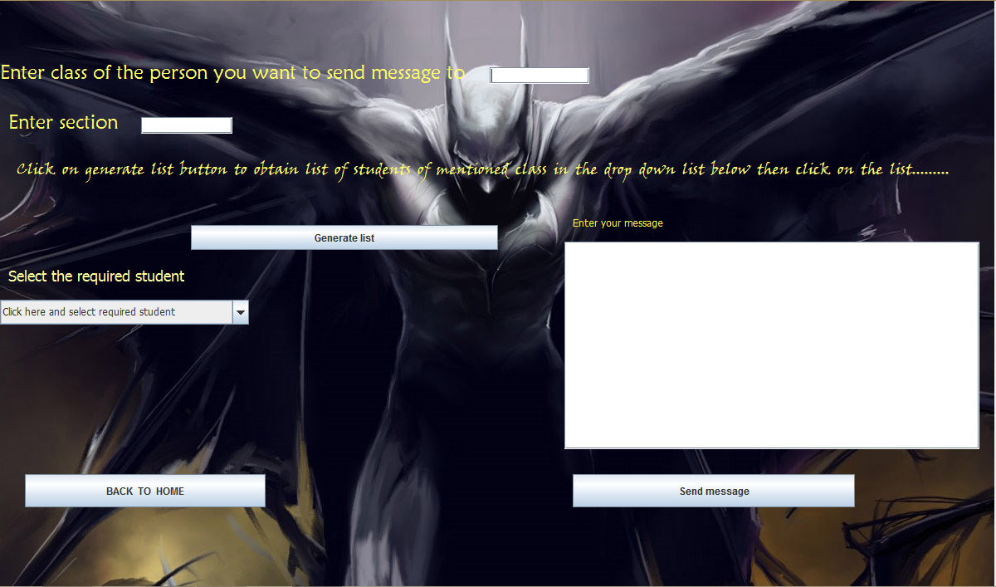**SEND MESSAGE FRAME :---**

***SOURCE CODE FOR SEND MESSAGE :---***

*CODE FOR (GENERATE LIST BUTTON) :---*

**int clas=Integer.parseInt(txtclass.getText());**

**String sec=txtsection.getText();**

**String name;**

**int rno,i=0;**

**try**

**{**

**Class.forName("java.sql.Driver");**

**Connection con=DriverManager.getConnection("jdbc:mysql://localhost:3306/yochat","root","mysql");**

**Statement stmt=con.createStatement();**

**String x="SELECT * FROM REGIST WHERE CLASS="+clas+" and section='"+sec+"' and userid not in(1,"+id+")";**

**ResultSet rs=stmt.executeQuery(x);**

**cbs.removeAllItems();**

**rs.first();**

**while(rs.next())**

**{**

**if(i==0)**

**rs.first();**

**name=rs.getString("name");**

**cbs.addItem(name);**

**i++; }**

**}catch(Exception e)**

**{JOptionPane.showMessageDialog(this,e.getMessage();}**

*CODE FOR (SEND MESSAGE BUTTON) :---*

**int messageid=1;**

**int user=id;**

**int clas=Integer.parseInt(txtclass.getText());**

**String sec=txtsection.getText();**

**String name=(String)cbs.getSelectedItem();**

**try**

**{**

**Class.forName("java.sql.Driver");**

**Connection con=DriverManager.getConnection("jdbc:mysql://localhost:3306/yochat","root","mysql");**

**Statement stmt=con.createStatement();**

**String x="SELECT * FROM REGIST WHERE CLASS="+clas+" and section='"+sec+"' and name='"+name+"'";**

**ResultSet rs=stmt.executeQuery(x);**

**rs.first();**

**int receiver=rs.getInt("userid");**

**String message=tam.getText();**

**String yoyo="SELECT * FROM MESSAG";**

**ResultSet rss=stmt.executeQuery(yoyo);**

**if(rss.last())**

**messageid=rss.getInt("messageid")+1;**

**else**

**messageid=1;**

**String hahaha="INSERT INTO MESSAG VALUES("+messageid+","+user+","+receiver+",'"+message+"','unseen')";**

**stmt.executeUpdate(hahaha);**

**JOptionPane.showMessageDialog(this,"Your message was succesfully sent");**

**}**

**catch(Exception e)**

**{**

**JOptionPane.showMessageDialog(this,e.getMessage()+"hahahahahahaahahahahahahahahah");**

**}**

**txtclass.setText("");**

**txtsection.setText("");**

**tam.setText("");**

**cbs.removeAllItems();**

**cbs.addItem("Click here and select required student");**

**}**

*CODE FOR (BACK BUTTON) :---*

**Uhome hh=new Uhome(id);**

**hh.setVisible(true);**

**this.setVisible(false);**

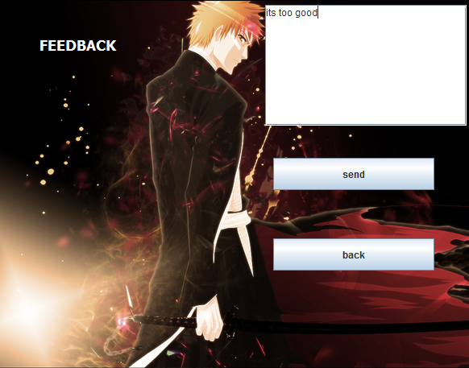

**FEEDBACK**

**FRAME**

***SOURCE CODE FOR FEEDBACK FRAME:-***

*CODE FOR (SEND BUTTON) :---*

**int user=id;**

**String f=taf.getText();**

**int fid;**

**try**

**{**

**Class.forName("java.sql.Driver");**

**Connection con=DriverManager.getConnection("jdbc:mysql://localhost:3306/yochat","root","root");**

**Statement stmt=con.createStatement();**

**String k="select * from feed";**

**ResultSet fg=stmt.executeQuery(k);**

**if(fg.last())**

**fid=fg.getInt("feedbackid")+1;**

**else**

**fid=1;**

**String jj="insert into feed values("+fid+",'"+f+"',"+user+",'null','seen')";**

**stmt.executeUpdate(jj);**

**taf.setText("");**

**}**

**catch(Exception e)**

**{**

**JOptionPane.showMessageDialog(this, e.getMessage());**

**}**

**}**

*CODE FOR (BACK BUTTON) :---*

**uhom g=new uhom(id);**

**g.setVisible(true);**

**this.setVisible(false);**

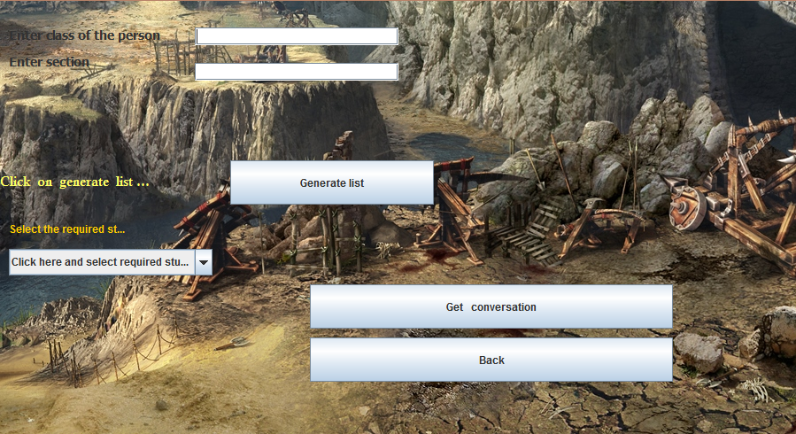

**OLDER**

**CONVERSATIONS**

**PART—1**

***SOURCE CODE FOR OLDER CONV. 1:---***

*CODE FOR (GENERATE LIST BUTTON) :---*

**int clas=Integer.parseInt(txtclass.getText());**

**String sec=txtsection.getText();**

**String name;**

**int rno,i=0;**

**try {**

**Class.forName("java.sql.Driver");**

**Connection con=DriverManager.getConnection("jdbc:mysql://localhost:3306/yochat","root","root");**

**Statement stmt=con.createStatement();**

**String x="SELECT * FROM REGIST WHERE CLASS="+clas+" and section='"+sec+"' and userid not in(1,"+id+")";**

**ResultSet rs=stmt.executeQuery(x);**

**cbs.removeAllItems();**

**rs.first();**

**while(rs.next()) {**

**if(i==0)**

**rs.first();**

**name=rs.getString("name");**

**cbs.addItem(name);**

**i++; }**

**} catch(Exception e) { } }**

*CODE FOR (GET CONVERSATION BUTTON) :---*

**int clas=Integer.parseInt(txtclass.getText());**

**String sec=txtsection.getText();**

**String name=(String)cbs.getSelectedItem();**

**try {**

**Class.forName("java.sql.Driver");**

**Connection con=DriverManager.getConnection("jdbc:mysql://localhost:3306/yochat","root","mysql");**

**Statement stmt=con.createStatement();**

**String x="SELECT * FROM REGIST WHERE CLASS="+clas+" and section='"+sec+"' and name='"+name+"'";**

**ResultSet rs=stmt.executeQuery(x);**

**rs.first();**

**int other=rs.getInt("userid");**

**Uolderconversation2 c=new Uolderconversation2(id,other);**

**c.setVisible(true);**

**this.setVisible(false);**

**}**

**catch(Exception e)**

**{**

**JOptionPane.showMessageDialog(this,e.getMessage()); } }**

*CODE FOR (BACK BUTTON) :---*

**uhom jj=new uhom(id);**

**jj.setVisible(true);**

**this.setVisible(false);**

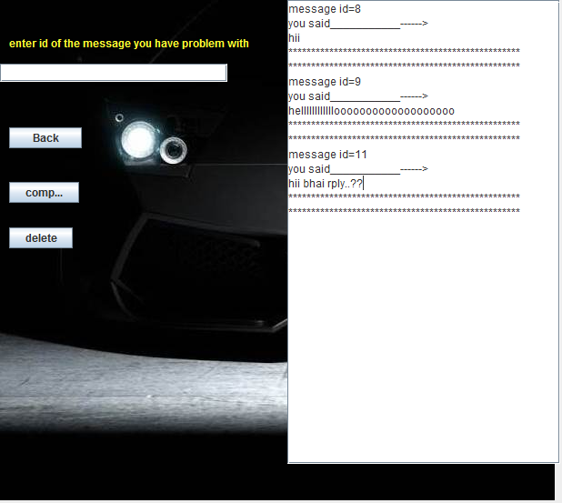

**OLDER**

**CONVERSATIONS**

**PART --- 2**

***SOURCE CODE FOR OLDER CONV. 2 :---***

*CODE FOR (WINDOW OPEN EVENT) :---*

**int user=id;**

**int other=ot;**

**int i=0,j=0,k=0;**

**String g;**

**try{**

**Class.forName("java.sql.Driver");**

**Connection con=DriverManager.getConnection("jdbc:mysql://localhost:3306/yochat","root","root");**

**Statement stmt=con.createStatement();**

**String hh="select * from regist where userid="+other;**

**ResultSet rshh=stmt.executeQuery(hh);**

**rshh.first();**

**String sname=rshh.getString("name");**

**String x="select * from messag where sender="+user+" or receiver="+user;**

**ResultSet rs=stmt.executeQuery(x);**

**rs.first();**

**do {**

**int s=rs.getInt("sender");**

**if(j==0)**

**rs.first();**

**if(s==user){**

**String m=rs.getString("message");**

**int mid=rs.getInt("messageid");**

**tam.append("message id="+mid+"\n");**

**tam.append("you said___________------>\n");**

**tam.append(m+"\n");**

**tam.append("***************************************************\n");**

**tam.append("***************************************************\n");**

**}**

**else if(s==other){**

**String m=rs.getString("message");**

**int mid=rs.getInt("messageid");**

**tam.append("message id="+mid+"\n");**

**tam.append(sname+" said___________------>\n");**

**tam.append(m+"\n");**

**tam.append("***************************************************\n");**

**tam.append("***************************************************\n");**

**}**

**j++;**

**} while(rs.next());}**

**catch(Exception e)**

**{**

**}**

**}**

*CODE FOR (DELETE BUTTON) :---*

**tam.setText("");**

**int mid=Integer.parseInt(txtmid.getText());**

**int user=id;**

**int other=ot;**

**int j=0;**

**String ff,m="";**

**try**

**{**

**Class.forName("java.sql.Driver");**

**Connection con=DriverManager.getConnection("jdbc:mysql://localhost:3306/yochat","root","mysql");**

**Statement stmt=con.createStatement();**

**String h="select name from regist where userid="+other;**

**ResultSet fg=stmt.executeQuery(h);**

**fg.first();**

**String nn=fg.getString("name");**

**ff="delete from messag where messageid="+mid;**

**stmt.executeUpdate(ff);**

**String x="select * from messag where sender="+user+" or receiver="+user;**

**ResultSet rs=stmt.executeQuery(x);**

**rs.first();**

**do**

**{**

**m=rs.getString("message");**

**int midv=rs.getInt("messageid");**

**j++;**

**int s=rs.getInt("sender");**

**int r=rs.getInt("receiver");**

**if(s==user && r==other){**

**tam.append("message id="+midv+"\n");**

**tam.append("you said___________------>\n");**

**tam.append(m+"\n");**

**tam.append("*************************\n");**

**tam.append("*************************\n");**

**}**

**else if(s==other && r==user){**

**tam.append("message id="+midv+"\n");**

**tam.append(nn+" said___________------>\n");**

**tam.append(m+"\n");**

**tam.append("***************************************************\n");**

**tam.append("***************************************************\n");**

**}**

**}while(rs.next());**

**}**

**catch(Exception e){}**

**txtmid.setText("");**

**}**

*CODE FOR (COMPLAIN BUTTON) :---*

**{**

**tam.setText("");**

**int mid=Integer.parseInt(txtmid.getText());**

**int user=id;**

**int other=ot,cid;**

**int j=0;**

**String ff;**

**try**

**{**

**Class.forName("java.sql.Driver");**

**Connection con=DriverManager.getConnection("jdbc:mysql://localhost:3306/yochat","root","mysql");**

**Statement stmt=con.createStatement();**

**String a="select * from messag where messageid="+mid;**

**ResultSet rsx=stmt.executeQuery(a);**

**rsx.first();**

**int s=rsx.getInt("sender");**

**int r=rsx.getInt("receiver");**

**String m=rsx.getString("message");**

**String b="select * from complain";**

**ResultSet rsa=stmt.executeQuery(b);**

**if(rsa.last())**

**cid=rsa.getInt("complaintid")+1;**

**else**

**cid=1;**

**if(s==id)**

**JOptionPane.showMessageDialog(this,"You can not complaint about your own message");**

**else{**

**String z="insert into complain values("+cid+","+r+","+s+",'"+m+"',null,null,'seen','seen',"+mid+")";**

**stmt.executeUpdate(z);**

**ff="delete from messag where messageid="+mid;**

**stmt.executeUpdate(ff);**

**}**

**String h="select name from regist where userid="+other;**

**ResultSet fg=stmt.executeQuery(h);**

**fg.first();**

**String nn=fg.getString("name");**

**String x="select * from messag where sender="+user+" or receiver="+user;**

**ResultSet rs=stmt.executeQuery(x);**

**rs.first();**

**do {**

**if(j==0)**

**m=rs.getString("message");**

**int midv=rs.getInt("messageid");**

**j++;**

**int sd=rs.getInt("sender");**

**int rd=rs.getInt("receiver");**

**if(sd==user && rd==other)**

**{**

**tam.append("message id="+midv+"\n");**

**tam.append("you said___________------>\n");**

**tam.append(m+"\n");**

**tam.append("*************************\n");**

**tam.append("*************************\n");**

**}**

**else if(sd==other && rd==user)**

**{**

**tam.append("message id="+midv+"\n");**

**tam.append(nn+" said___________------>\n");**

**tam.append(m+"\n");**

**tam.append("***************************************************\n");**

**tam.append("***************************************************\n");**

**}**

**}while(rs.next());}**

**catch(Exception e)**

**{**

**}**

**txtmid.setText("");**

**}**

*CODE FOR (BACK BUTTON) :---*

**int userid=id;**

**try**

**{**

**Class.forName("java.sql.Driver");**

**Connection con=DriverManager.getConnection("jdbc:mysql://localhost:3306/yochat","root","mysql");**

**Statement stmt=con.createStatement();**

**String x="update messag set status='yoyo' where receiver="+userid;**

**stmt.executeUpdate(x);**

**uhom nh=new uhom(id);**

**nh.setVisible(true);**

**this.setVisible(false);**

**}**

**catch(Exception e)**

**{**

**}**

**ADMINISTRATION**

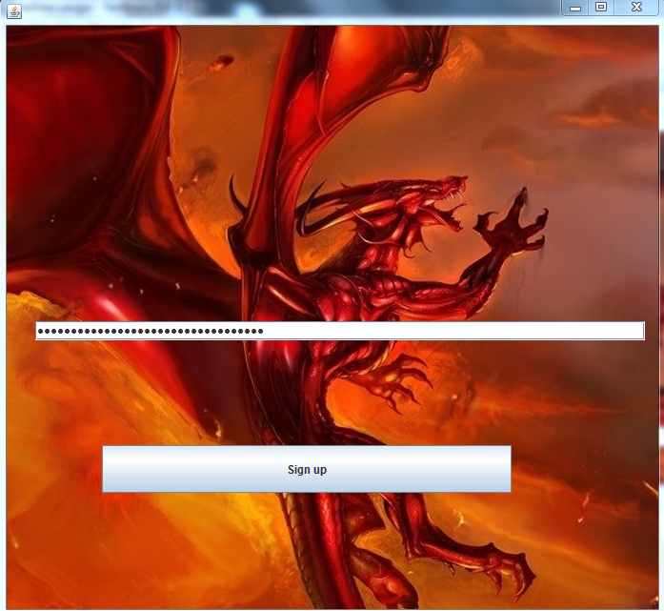**SIGN – UP**

**FRAME FOR**

**ADMINISTRATOR**

***SOURCE CODE FOR ADMIN. LOGIN :---***

*CODE FOR (SIGN UP BUTTON) :---*

**String p=txtp.getText();**

**if(p.equals("adityarajrajtripathisanjivrai"){**

**Ahome j=new Ahome();**

**j.setVisible(true);**

**this.setVisible(false); }**

**else {**

**JOptionPane.showMessageDialog(this,"You entered wrong password"); }**

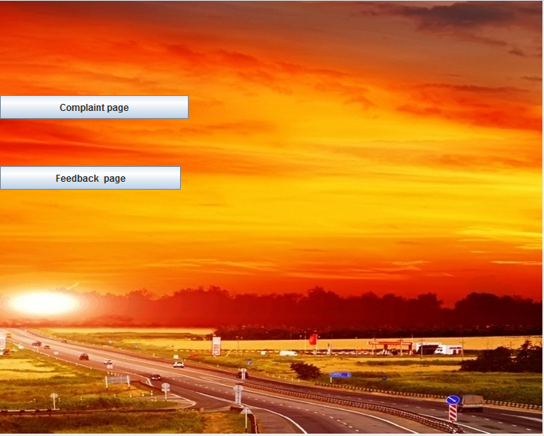**HOME PAGE**

**FOR**

**ADMINISTRATOR**

***SOURCE CODE FOR ADMIN HOME :---***

*CODE FOR (FEEDBACK PAGE BUTTON) :---*

**Afeedback jj=new Afeedback();**

**jj.setVisible(true);**

**this.setVisible(false);**

*CODE FOR (COMPLAINT PAGE BUTTON) :---*

**Acomplaint jj=new Acomplaint();**

**jj.setVisible(true);**

**this.setVisible(false);**

**COMPLAINT FRAME FOR ADMINISTRATION** 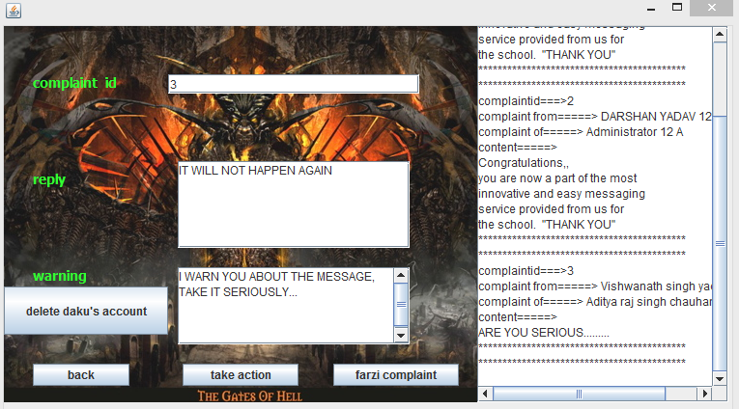

***SOURCE CODE FOR ADMIN COMLAINT:---***

*CODE FOR (WINDOW OPEN EVENT) :---*

**int i=0,j=0,k=0,l=9;**

**String g;**

**try{**

**Class.forName("java.sql.Driver");**

**Connection con=DriverManager.getConnection("jdbc:mysql://localhost:3306/yochat","root","root");**

**Statement stmt=con.createStatement();**

**do {**

**String x="select * from complain where statushero='seen'";**

**ResultSet rs=stmt.executeQuery(x);**

**rs.last();**

**int ccc=rs.getInt("complaintid");**

**rs.first();**

**k=j;**

**if(k!=0){**

**do{**

**rs.next();**

**k--;**

**}while(k!=0);}**

**int cccc=rs.getInt("complaintid");**

**if(ccc==cccc)**

**l=0;**

**if(l==1)**

**i=1;**

**if(i==0){**

**int c=rs.getInt("complaintid");**

**int m=rs.getInt("messageid");**

**int r=rs.getInt("hero");**

**int s=rs.getInt("daku");**

**String w=rs.getString("content");**

**int coid=rs.getInt("complaintid");**

**g="select * from regist where userid="+r;**

**ResultSet rsg=stmt.executeQuery(g);**

**rsg.first();**

**String rname=rsg.getString("name");**

**int rclass=rsg.getInt("class");**

**String rsection=rsg.getString("section");**

**String h="select * from regist where userid="+s;**

**ResultSet rsh=stmt.executeQuery(h);**

**rsh.first();**

**String sname=rsh.getString("name");**

**int sclass=rsh.getInt("class");**

**String ssection=rsh.getString("section");**

**tac.append("complaintid===>"+coid+"\n");**

**tac.append("complaint from=====>"+" "+rname+" "+rclass+" "+rsection+"\n");**

**tac.append("complaint of=====>"+" "+sname+" "+sclass+" "+ssection+"\n");**

**tac.append("content=====>\n");**

**tac.append(w+"\n");**

**tac.append("*******************************************\n");**

**tac.append("*******************************************\n");**

**j++;**

**l++;**

**} }while(i==0 && i!=1);**

**}**

**catch(Exception e){}**

**}**

*CODE FOR (TAKE ACTION BUTTON) :---*

**int i=0,j=0,k=0,l=9;**

**String g;**

**try{**

**Class.forName("java.sql.Driver");**

**Connection con=DriverManager.getConnection("jdbc:mysql://localhost:3306/yochat","root","mysql");**

**Statement stmt=con.createStatement();**

**int coi=Integer.parseInt(cid.getText());**

**String d=tar.getText();**

**String h=taw.getText();**

**String o="update complain set warning='"+h+"' where complaintid="+coi;**

**String y="update complain set reply='"+d+"' where complaintid="+coi;**

**String z="update complain set statushero='unseen' where complaintid="+coi;**

**String v="update complain set statusdaku='unseen' where complaintid="+coi;**

**stmt.executeUpdate(o);**

**stmt.executeUpdate(y);**

**stmt.executeUpdate(z);**

**stmt.executeUpdate(v);**

**tac.setText("");**

**do {**

**String x="select * from complain where statushero='seen'";**

**ResultSet rs=stmt.executeQuery(x);**

**rs.last();**

**int ccc=rs.getInt("complaintid");**

**rs.first();**

**k=j;**

**if(k!=0){**

**do{**

**rs.next();**

**k--;**

**}while(k!=0);}**

**int cccc=rs.getInt("complaintid");**

**if(ccc==cccc)**

**l=0;**

**if(l==1)**

**i=1;**

**if(i==0) {**

**int c=rs.getInt("complaintid");**

**int m=rs.getInt("messageid");**

**int r=rs.getInt("hero");**

**int s=rs.getInt("daku");**

**String w=rs.getString("content");**

**int coid=rs.getInt("complaintid");**

**g="select * from regist where userid="+r;**

**ResultSet rsg=stmt.executeQuery(g);**

**rsg.first();**

**String rname=rsg.getString("name");**

**int rclass=rsg.getInt("class");**

**String rsection=rsg.getString("section");**

**String hh="select * from regist where userid="+s;**

**ResultSet rsh=stmt.executeQuery(hh);**

**rsh.first();**

**String sname=rsh.getString("name");**

**int sclass=rsh.getInt("class");**

**String ssection=rsh.getString("section");**

**tac.append("complaintid===>"+coid+"\n");**

**tac.append("complaint from=====>"+" "+rname+" "+rclass+" "+rsection+"\n");**

**tac.append("complaint of=====>"+" "+sname+" "+sclass+" "+ssection+"\n");**

**tac.append("content=====>\n");**

**tac.append(w+"\n");**

**tac.append("*******************************************\n");**

**tac.append("*******************************************\n");**

**j++;**

**l++; }**

**}while(i==0 && i!=1);**

**}**

**catch(Exception e)**

**{ }}**

*CODE FOR (FARZI COMPLAINT BUTTON) :---*

**int i=0,j=0,k=0;**

**String g;**

**try{**

**Class.forName("java.sql.Driver");**

**Connection con=DriverManager.getConnection("jdbc:mysql://localhost:3306/yochat","root","mysql");**

**Statement stmt=con.createStatement();**

**int cmid=Integer.parseInt(cid.getText());**

**String d="delete from complain where complaintid="+cmid;**

**stmt.executeUpdate(d);**

**tac.setText("");**

**do**

**{**

**String x="select * from complain where statushero='seen'";**

**ResultSet rs=stmt.executeQuery(x);**

**rs.first();**

**k=j;**

**if(k!=0){**

**do{**

**rs.next();**

**k--;**

**}while(k!=0); }**

**if(rs.next())**

**i=0;**

**else**

**i=1;**

**if(i==0) {**

**int c=rs.getInt("complaintid");**

**int m=rs.getInt("messageid");**

**int r=rs.getInt("hero");**

**int s=rs.getInt("daku");**

**String w=rs.getString("content");**

**int coid=rs.getInt("complaintid");**

**g="select * from regist where userid="+r;**

**ResultSet rsg=stmt.executeQuery(g);**

**rsg.first();**

**String rname=rsg.getString("name");**

**int rclass=rsg.getInt("class");**

**String rsection=rsg.getString("section");**

**String h="select * from regist where userid="+s;**

**ResultSet rsh=stmt.executeQuery(h);**

**rsh.first();**

**String sname=rsh.getString("name");**

**int sclass=rsh.getInt("class");**

**String ssection=rsh.getString("section");**

**tac.append("complaintid===>"+coid+"\n");**

**tac.append("complaint from=====>"+" "+rname+" "+rclass+" "+rsection+"\n");**

**tac.append("complaint of=====>"+" "+sname+" "+sclass+" "+ssection+"\n");**

**tac.append("content=====>\n");**

**tac.append(w+"\n");**

**tac.append("*******************************************\n");**

**tac.append("*******************************************\n");**

**j++;**

**}**

**}while(i==0);}**

**catch(Exception e)**

**{} }**

*CODE FOR (BACK BUTTON) :---*

**Ahome h=new Ahome();**

**h.setVisible(true);**

**this.setVisible(false);**

**}**

*CODE FOR (DELETE DAKU’S ACCOUNT BUTTTON) :---*

**int i=0,j=0,k=0;**

**String g;**

**try**

**{**

**Class.forName("java.sql.Driver");**

**Connection con=DriverManager.getConnection("jdbc:mysql://localhost:3306/yochat","root","mysql");**

**Statement stmt=con.createStatement();**

**//x,rs,k,j,i,c,m,r,s,w,coid,g,h**

**int coi=Integer.parseInt(cid.getText());**

**String f="select * from complain where complaintid="+coi;**

**ResultSet rsf=stmt.executeQuery(f);**

**rsf.first();**

**int daku=rsf.getInt("daku");**

**String reg="delete from regist where userid="+daku;**

**String fee="delete from feed where senderid="+daku;**

**String mes="delete from messag where sender="+daku+" or receiver="+daku;**

**String com="delete from complain where hero="+daku+" or daku="+daku;**

**stmt.executeUpdate(reg);**

**stmt.executeUpdate(fee);**

**stmt.executeUpdate(mes);**

**stmt.executeUpdate(com);**

**do**

**{**

**String x="select * from complain where statushero='seen'";**

**ResultSet rs=stmt.executeQuery(x);**

**rs.first();**

**k=j;**

**if(k!=0)**

**{**

**do{**

**rs.next();**

**k--;**

**}while(k!=0);}**

**if(rs.next())**

**i=0;**

**else**

**i=1;**

**if(i==0)**

**{**

**int c=rs.getInt("complaintid");**

**int m=rs.getInt("messageid");**

**int r=rs.getInt("hero");**

**int s=rs.getInt("daku");**

**String w=rs.getString("content");**

**int coid=rs.getInt("complaintid");**

**g="select * from regist where userid="+r;**

**ResultSet rsg=stmt.executeQuery(g);**

**rsg.first();**

**String rname=rsg.getString("name");**

**int rclass=rsg.getInt("class");**

**String rsection=rsg.getString("section");**

**String h="select * from regist where userid="+s;**

**ResultSet rsh=stmt.executeQuery(h);**

**rsh.first();**

**String sname=rsh.getString("name");**

**int sclass=rsh.getInt("class");**

**String ssection=rsh.getString("section");**

**tac.append("complaintid===>"+coid+"\n");**

**tac.append("complaint from=====>"+" "+rname+" "+rclass+" "+rsection+"\n");**

**tac.append("complaint of=====>"+" "+sname+" "+sclass+" "+ssection+"\n");**

**tac.append("content=====>\n");**

**tac.append(w+"\n");**

**tac.append("*******************************************\n");**

**tac.append("*******************************************\n");**

**j++;**

**}**

**}while(i==0);**

**}**

**catch(Exception e)**

**{**

**}**

**FEEDBACK PAGE FOR ADMINISTRATOR :--**

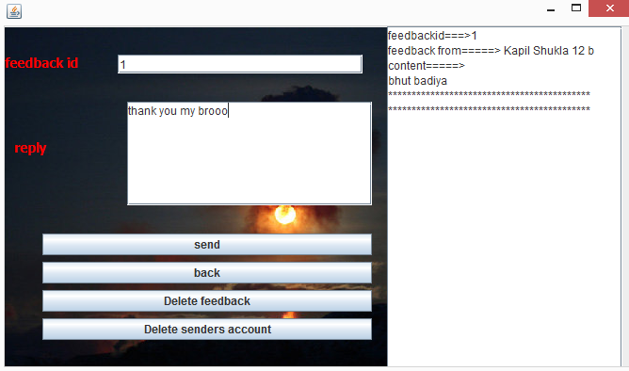

***SOURCE CODE FOR ADMIN COMLAINT:---***

*CODE FOR (WINDOW OPEN EVENT) :---*

**int i=0,j=0,k=0,l=9;**

**String g;**

**try{**

**Class.forName("java.sql.Driver");**

**Connection con=DriverManager.getConnection("jdbc:mysql://localhost:3306/yochat","root","root");**

**Statement stmt=con.createStatement();**

**do {**

**String x="select * from feed where status='seen'";**

**ResultSet rs=stmt.executeQuery(x);**

**rs.last();**

**int ccc=rs.getInt("feedbackid");**

**rs.first();**

**k=j;**

**if(k!=0)**

**}**

**do {**

**rs.next();**

**k--;**

**}while(k!=0);**

**}**

**int cccc=rs.getInt("feedbackid");**

**if(ccc==cccc)**

**l=0;**

**if(l==1)**

**i=1;**

**if(i==0)**

**{**

**int id=rs.getInt("feedbackid");**

**int s=rs.getInt("senderid");**

**String f=rs.getString("feedback");**

**String h="select * from regist where userid="+s;**

**ResultSet rsh=stmt.executeQuery(h);**

**rsh.first();**

**String sname=rsh.getString("name");**

**int sclass=rsh.getInt("class");**

**String ssection=rsh.getString("section");**

**taf.append("feedbackid===>"+id+"\n");**

**taf.append("feedback from=====>"+" "+sname+" "+sclass+" "+ssection+"\n");**

**taf.append("content=====>\n");**

**taf.append(f+"\n");**

**taf.append("*******************************************\n");**

**taf.append("*******************************************\n");**

**j++;**

**l++;**

**} }while(i==0);**

**}**

**catch(Exception e)**

**{} }**

*CODE FOR (SEND BUTTON) :---*

**int i=0,j=0,k=0,l=9;**

**String g;**

**int foid=Integer.parseInt(fid.getText());**

**String hj=tar.getText();**

**String y="update feed set reply='"+hj+"' where feedbackid="+foid;**

**String z="update feed set status='unseen' where feedbackid="+foid;**

**try {**

**Class.forName("java.sql.Driver");**

**Connection con=DriverManager.getConnection("jdbc:mysql://localhost:3306/yochat","root","mysql");**

**Statement stmt=con.createStatement();**

**stmt.executeUpdate(y);**

**stmt.executeUpdate(z);**

**taf.setText("");**

**do {**

**String x="select * from feed where status='seen'";**

**ResultSet rs=stmt.executeQuery(x);**

**rs.last();**

**int ccc=rs.getInt("feedbackid");**

**rs.first();**

**k=j;**

**if(k!=0){**

**do{**

**rs.next();**

**k--;**

**}while(k!=0);}**

**int cccc=rs.getInt("feedbackid");**

**if(ccc==cccc)**

**l=0;**

**if(l==1)**

**i=1;**

**if(i==0). {**

**int id=rs.getInt("feedbackid");**

**int s=rs.getInt("senderid");**

**String f=rs.getString("feedback");**

**String h="select * from regist where userid="+s;**

**ResultSet rsh=stmt.executeQuery(h);**

**rsh.first();**

**String sname=rsh.getString("name");**

**int sclass=rsh.getInt("class");**

**String ssection=rsh.getString("section");**

**taf.append("feedbackid===>"+id+"\n");**

**taf.append("feedback from=====>"+" "+sname+" "+sclass+" "+ssection+"\n");**

**taf.append("content=====>\n");**

**taf.append(f+"\n");**

**taf.append("*******************************************\n");**

**taf.append("*******************************************\n");**

**j++;**

**l++; }**

**}while(i==0);**

**}**

**catch(Exception e)**

**{}**

**fid.setText("");**

**tar.setText("");**

*CODE FOR (BACK BUTTON) :---*

**Ahome hg=new Ahome();**

**hg.setVisible(true);**

**this.setVisible(false);**

**fid.setText("");**

**tar.setText("");**

*CODE FOR (DELETE FEEDBACK BUTTON) :---*

**int i=0,j=0,k=0,l=9;**

**try {**

**Class.forName("java.sql.Driver");**

**Connection con=DriverManager.getConnection("jdbc:mysql://localhost:3306/yochat","root","mysql");**

**Statement stmt=con.createStatement();**

**int foid=Integer.parseInt(fid.getText());**

**String io="delete from feed where feedbackid="+foid;**

**stmt.executeUpdate(io);**

**taf.setText("");**

**do {**

**String x="select * from feed where status='seen'";**

**ResultSet rs=stmt.executeQuery(x);**

**rs.last();**

**int ccc=rs.getInt("feedbackid");**

**rs.first();**

**k=j;**

**if(k!=0){**

**do{**

**rs.next();**

**k--;**

**}while(k!=0);}**

**int cccc=rs.getInt("feedbackid");**

**if(ccc==cccc)**

**l=0;**

**if(l==1)**

**i=1;**

**if(i==0) {**

**int id=rs.getInt("feedbackid");**

**int s=rs.getInt("senderid");**

**String f=rs.getString("feedback");**

**String h="select * from regist where userid="+s;**

**ResultSet rsh=stmt.executeQuery(h);**

**rsh.first();**

**String sname=rsh.getString("name");**

**int sclass=rsh.getInt("class");**

**String ssection=rsh.getString("section");**

**taf.append("feedbackid===>"+id+"\n");**

**taf.append("feedback from=====>"+" "+sname+" "+sclass+" "+ssection+"\n");**

**taf.append("content=====>\n");**

**taf.append(f+"\n");**

**taf.append("*******************************************\n");**

**taf.append("*******************************************\n");**

**j++; l++;**

**}}while(i==0);**

**}**

**catch(Exception e)**

**{}**

**fid.setText("");**

**tar.setText("");**

*CODE FOR (DELETE SENDER’) :---*

**int i=0,j=0,k=0,l=9;**

**try{**

**Class.forName("java.sql.Driver");**

**Connection con=DriverManager.getConnection("jdbc:mysql://localhost:3306/yochat","root","mysql");**

**Statement stmt=con.createStatement();**

**int foid=Integer.parseInt(fid.getText());**

**String io="delete from feed where feedbackid="+foid;**

**stmt.executeUpdate(io);**

**String iop="select * from feed where feedbackid="+foid;**

**ResultSet rss=stmt.executeQuery(iop);**

**rss.first();**

**int daku=rss.getInt("senderid");**

**String reg="delete from regist where userid="+daku;**

**String fee="delete from feed where senderid="+daku;**

**String mes="delete from messag where sender="+daku+" or receiver="+daku;**

**String com="delete from complain where hero="+daku+" or daku="+daku;**

**stmt.executeUpdate(reg);**

**stmt.executeUpdate(fee);**

**stmt.executeUpdate(mes);**

**stmt.executeUpdate(com);**

**taf.setText("");**

**do {**

**String x="select * from feed where status='seen'";**

**ResultSet rs=stmt.executeQuery(x);**

**rs.last();**

**int ccc=rs.getInt("feedbackid");**

**rs.first();**

**k=j;**

**if(k!=0) {**

**do{**

**rs.next();**

**k--;**

**}while(k!=0);**

**}**

**int cccc=rs.getInt("feedbackid");**

**if(ccc==cccc)**

**l=0;**

**if(l==1)**

**i=1;**

**if(i==0)**

**{**

**int id=rs.getInt("feedbackid");**

**int s=rs.getInt("senderid");**

**String f=rs.getString("feedback");**

**String h="select * from regist where userid="+s;**

**ResultSet rsh=stmt.executeQuery(h);**

**rsh.first();**

**String sname=rsh.getString("name");**

**int sclass=rsh.getInt("class");**

**String ssection=rsh.getString("section");**

**taf.append("feedbackid===>"+id+"\n");**

**taf.append("feedback from=====>"+" "+sname+" "+sclass+" "+ssection+"\n");**

**taf.append("content=====>\n");**

**taf.append(f+"\n");**

**taf.append("*******************************************\n");**

**taf.append("*******************************************\n");**

**j++;**

**l++;**

**}**

**}while(i==0);**

**}**

**catch(Exception e)**

**{**

**JOptionPane.showMessageDialog(this,e.getMessage());**

**}**

**fid.setText("");**

**tar.setText("");**